INFORMATION



BOOKLET

CONTENTS

- Contact Details Page 3
- Jigsaw Staff Page 4
- School Day Page 5–6
- Uniform / P.E. Kit Page 7
- Break/Lunch Page 8
- Quiet Rooms Page 9
- E-Safety Page 10
- GDPR Privacy Notice Page 11-14
- Transport Page 15-18
- Clyde the School Dog Page 19
- Float Therapy Page 20
- ELSA Support Page 21
- Safeguarding Page 22
- Attendance Page 23-24

CONTACT INFORMATION

Jigsaw
Stannyfield Drive
Thornton
L23 1TY

Telephone: 0151 934 2485
Mobile: 07587021703 (School Hours)
Email: jigsaw@schools.sefton.gov.uk
Website: www.jigsawpru.co.uk


JIGSAW STAFF

Headteacher: Ms Erika Rothlisberger
Deputy Headteacher: Mr Chris Mathews
Office Manager: Mrs Jan Woods
Administrator: Mrs Amy Swindells
Liaison Officer: Mrs Sarah King
Class 1 Teacher: Mr Shaun O’Hara
Class 2 Teacher: Mrs Elizabeth Lee
Class 3 Teacher: Mr Dominic Cooke
Support Staff: Mrs Claire Green
Miss Helen Roper
Mrs Kristine Fawcett
Miss Ellen Monaghan
Mrs Kate Owen
Miss Stephanie Dewsbury
Miss Marissa Hannon (Apprentice)
Caretaker: Mr Roger Jones
Cleaner/Lunchtime Asst: Mrs Sue Watson

CLASS ONE TIMETABLE



9.00 – 9.30 | Learning Readiness / Toast
9.30 – 10.00 | Phonics
10.00 – 10.45 | Maths
10.45 – 11.00 | Playtime
11.00 – 11.15 | Fruit / Story / Class Reader
11.15 – 11.45 | English
11.45 – 12.15 | Continuous Provision / Assembly
12.15 – 1.00 | Lunch / Playtime
1.00 – 1.15 | Reading to Adult
1.15 – 2.10 | Topic/History/PE/ Science/PSHE
2.10 – 2.25 | Continuous Provision
2.25 – 2.30 | Stars / Home time

*PE IS CURRENTLY EVERY WEDNESDAY IN CLASS ONE

CLASS TWO/THREE TIMETABLE

9.00 – 9.30 | Morning Maths/Phonics
9.30 – 9.45 | Newsround
9.45-10.00 | Assembly
10.00- 10.45 | Maths
10.45 – 11.00 | Playtime
11.00 – 11.30 | Teacher Led Reading
11.30 – 12.15 | English
11.30-12.15 | Continuous Provision / Assembly
12.15 – 1.00 | Lunch / Playtime
1.00 – 1.30 | Reading / IDL
1.30 – 2.15 | Topic/History/PE*/ Science/PSHE/Computing
2.15 – 2.30 | Daily Diaries / Rewards / Home time

*PE IS CURRENTLY EVERY FRIDAY IN CLASS TWO/THREE

UNIFORM


Pupils are expected to wear their full school uniform at all times. This includes schools shoes or black trainers (no other trainers allowed).
- School Dark Trousers / Skirt
- School Shirt / Polo Shirt
- School Jumper / Sweatshirt / Cardigan
Summer options:
- School Shorts and Polo Shirt
- School Summer Dress

PE KIT
Key Stage 1 PE is on Wednesday and Key Stage 2 PE is Friday – please send your son/daughter in their PE Kit on these days.

- Plain Black Shorts / Tracksuit Bottoms
- Plain White T-Shirt / Polo Shirt
- Black Pumps / Trainers

BREAKS

There are two break times in the school day and pupils have access to an outside play area.
In addition Key Stage 1 pupils have access to a secure outdoor classroom area.
Pupils are supervised at all times. Pupils are encouraged to play co-operatively and when it is felt necessary, staff may intervene to initiate more structured play.
During wet weather pupils will be offered alternative indoor space and activities.
SNACK / LUNCH

Jigsaw provides toast and fruit everyday as morning snack.
Free school lunches will be provided to all Key Stage 1 pupils and Key Stage 2 pupils who are eligible to receive them. If you pay for your son/daughter’s meals please send cash into school, meals are currently £2.60 per day.
Please feel free to send in packed lunches if preferred but note we do not allow the following in packed lunches: fizzy drinks, sweets or chocolate.
All staff and pupils sit down together for snack and lunch, this allows us an opportunity to model and encourage positive social behaviours.
CLASSROOM QUIET ROOMS

At Jigsaw our Quiet Room is an area for a pupil to safely calm and prepare to return to his/her class. Quiet rooms are used together with a Positive Handling Plan and is included as part of our Care and Control Policy. Please ask at the office if you wish to see this policy.
The Quiet Room offers a quiet and safe area for pupils who may be:
Overwhelmed
Experiencing over-stimulation
Exhibiting behaviours, which may cause themselves and others harm
Require a quiet place to learn or be part of a planned activity

Physical Intervention
Sometimes it is reasonable to use supportive physical interventions – use of ‘caring c’ to prompt or guide. In such circumstances it may be reasonable to withdraw a child to a safer place. All responses to extreme behaviour should be reasonable, proportionate and necessary and all staff are asked to use a dynamic risk assessment and consult Positive Handling Plans before physical intervention is used.

e-Safety Rules



These e-Safety Rules help to protect pupils and the school by describing acceptable and unacceptable computer use.
- The school owns the computer network and can set rules for its use.
- It is a criminal offence to use a computer or network for a purpose not permitted by the school.
- Irresponsible use may result in the loss of network or Internet access.
- Network access must be made via the user’s authorised account and password, which must not be given to any other person.
- All network and Internet use must be appropriate to education.
- Copyright and intellectual property rights must be respected.
- Messages shall be written carefully and politely, particularly as email could be forwarded to unintended readers.
- Anonymous messages and chain letters are not permitted.
- Users must take care not to reveal personal information through email, personal publishing, blogs or messaging.
- The school ICT systems may not be used for private purposes, unless the head teacher has given specific permission.
- Use for personal financial gain, gambling, political activity, advertising or illegal purposes is not permitted.

The school may exercise its right to monitor the use of the school’s computer systems, including access to web-sites, the interception of e-mail and the deletion of inappropriate materials where it believes unauthorised use of the school’s computer system may be taking place, or the system may be being used for criminal purposes or for storing unauthorised or unlawful text, imagery or sound.

GDPR Privacy Notice for Pupils and their Families


Who processes your information?
Jigsaw is the data controller of the personal information you provide to us. This means the school determines the purposes for which, and the manner in which, any personal data relating to pupils and their families is to be processed. Amy Swindells acts as a representative for the school with regard to its data controller responsibilities; they can be contacted on 0151 934 2485 or jigsaw@schools.sefton.gov.uk.
In some cases, your data will be outsourced to a third party processor; however, this will only be done with your consent, unless the law requires the school to share your data. Where the school outsources data to a third party processor, the same data protection standards that Jigsaw upholds are imposed on the processor.
Nick Holden is the data protection officer. Their role is to oversee and monitor the school’s data protection procedures, and to ensure they are compliant with the GDPR. The data protection officer can be contacted on 08454 631 072 or dpo.jigsaw@schools.sefton.gov.uk.
Why do we collect and use your information?
Jigsaw holds the legal right to collect and use personal data relating to pupils and their families, and we may also receive information regarding them from their previous school, LA and/or the DfE. We collect and use personal data in order to meet legal requirements and legitimate interests set out in the GDPR and UK law, including those in relation to the following:
- Article 6 and Article 9 of the GDPR
- Education Act 1996
- Section 3 of The Education (Information About Individual Pupils) (England) Regulations 2013

In accordance with the above, the personal data of pupils and their families is collected and used for the following reasons:

- To support pupil learning
- To monitor and report on pupil progress
- To provide appropriate pastoral care
- To assess the quality of our service
- To comply with the law regarding data sharing
Which data is collected?
The categories of pupil information that the school collects, holds and shares include the following:
- Personal information – e.g. names, pupil numbers and addresses
- Characteristics – e.g. ethnicity, language, nationality, country of birth and free school meal eligibility
- Attendance information – e.g. number of absences and absence reasons
- Assessment information – e.g. national curriculum assessment results
- Relevant medical information
- Information relating to SEND
- Behavioural information – e.g. number of temporary exclusions
Whilst the majority of the personal data you provide to the school is mandatory, some is provided on a voluntary basis. When collecting data, the school will inform you whether you are required to provide this data or if your consent is needed. Where consent is required, the school will provide you with specific and explicit information with regards to the reasons the data is being collected and how the data will be used.
How long is your data stored for?
Personal data relating to pupils at Jigsaw and their families is stored in line with the school’s GDPR Data Protection Policy.
In accordance with the GDPR, the school does not store personal data indefinitely; data is only stored for as long as is necessary to complete the task for which it was originally collected.
Will my information be shared?
The school is required to share pupils’ data with the DfE on a statutory basis, this includes the following:
The National Pupil Database (NPD) is managed by the DfE and contains information about pupils in schools in England. Jigsaw is required by law to provide information about our pupils to the DfE as part of statutory data collections, such as the school census; some of this information is then stored in the NPD. The DfE may share information about our pupils from the NDP with third parties who promote the education or wellbeing of children in England by:
- Conducting research or analysis.
- Producing statistics.
- Providing information, advice or guidance.
The DfE has robust processes in place to ensure the confidentiality of any data shared from the NDP is maintained.
Jigsaw will not share your personal information with any third parties without your consent, unless the law allows us to do so. The school routinely shares pupils’ information with:
- Pupils’ destinations upon leaving the school
- The Local Authority
- The NHS
The information that we share with these parties includes the following:
• Personal information – e.g. names, pupil numbers and addresses
• Characteristics – e.g. ethnicity, language, nationality, country of birth and free school meal eligibility
• Attendance information – e.g. number of absences and absence reasons
• Assessment information – e.g. national curriculum assessment results
• Relevant medical information
• Information relating to SEND
• Behavioural information – e.g. number of temporary exclusions
- Safeguarding Information where relevant
Parents are able to request that only their child’s name, address and date of birth are passed to the LA or name of provider of youth support services, by informing name of school administrator via email or letter. Once pupils reach 16 years of age, this right is transferred to them, rather than their parents. For more information regarding services for young people, please visit our LA’s website: LA’s website link.
We are also required to pass certain personal information to careers services once pupils reach the age of 16. The information accessible by careers services includes details of information passed on to careers services.

What are your rights?
Parents and pupils have the following rights in relation to the processing of their personal data.
You have the right to:
- Be informed about how Jigsaw uses your personal data.
- Request access to the personal data that Jigsaw holds.
- Request that your personal data is amended if it is inaccurate or incomplete.
- Request that your personal data is erased where there is no compelling reason for its continued processing.
- Request that the processing of your data is restricted.
- Object to your personal data being processed.
Where the processing of your data is based on your consent, you have the right to withdraw this consent at any time.
If you have a concern about the way Jigsaw and/or the DfE is collecting or using your personal data, you can raise a concern with the Information Commissioner’s Office (ICO). The ICO can be contacted on 0303 123 1113, Monday-Friday 9am-5pm.
You are entitled to submit subject access requests all year round, but please bear in mind that it may be necessary for us to extend the response period when requests are submitted over the summer holidays. This is in accordance with article 12(3) of the GDPR, and will be the case where the request is complex – for example, where we need multiple staff to collect the data.
Where can you find out more information?
If you would like to find out more information about how we and/or the DfE collect, use and store your personal data, please visit our website http://www.jigsawpru.co.uk to download our GDPR Data Protection Policy.

JIGSAW TRANSPORT



A minibus or taxi will pick your child up from and drop them off at home.
There is an escort on board to ensure your child arrives at Jigsaw safely.
All drivers and escorts have up to date DBS enhanced checks.
Please note transport provided by Jigsaw is not a legal requirement and may be withdrawn if there is inappropriate conduct, especially behaviour that may present a risk to self or others.
You will sign a transport agreement prior to your child accessing a bus or taxi which states that a high standard of behaviour is expected, this keeps all pupils safe.

The agreement states the following:
Parents/Carers
I/we will:
Ensure that Jigsaw is informed as soon as possible if our/my child cannot attend for whatever reason.
Ensure our/my child is ready to be picked up in the morning without causing delay to the transport.
Keep to the arranged dropping off schedule.
Make sure an appropriate named adult is at home/agreed dropping off point to receive our/my child.
Notify Jigsaw, with as much notice as possible of any unavoidable changes. Changes must be permanent.
Pupil
Will:
Be ready to be picked up in the morning.
Show respect at all times (vehicle, driver, escort and other pupils)
Do as I am asked to do
Sit where I am told
Use appropriate language
Only take part in appropriate conversations
Commissioned Transport Offer
This service is to ensure your child will arrive safely at the start of the school day and be ready to learn.
- Transport will usually be on a bus or minibus. Where there are multiple service users there will be a passenger assistant to supervise and help and provide basic first aid in the case of an emergency.

- We will provide a door to door service or pick up from bus stops as required or requested by the service users, with an aim to encourage independent travelling skills whenever possible.

- To arrive at the start of the school day, a pickup time will be specified by the contractor. Whilst they will endeavour to achieve that time there may be short delays due traffic or delays with other service users.

- Where we have established a routine, we will endeavour to keep it, but be we will need to make changes from time to time. In such instances you can expect reasonable notice. Similarly, as much notice as possible will be given in the event of a change of transport staff.

- During extreme weather conditions when we cannot transport your child safely transport will be cancelled for the whole day and in such circumstances, you may need to make alternative arrangements.

- Whilst we have a zero-tolerance stance on abuse or violence from members of public against staff, we recognise that service users have different needs and any instances relating to service users will be looked at on an individual basis but will typically result in temporary suspension of service.

- When collecting service users if staff feel that it is unsafe to transport them, for example during an incident of extremely challenging behaviour, they may on occasion refuse to transport them. In these instances, it is the responsibility of parents and/or school to make alternative travelling arrangements.

- Changes to pick up or drop off times cannot be accommodated even for work or sibling related timing issues. It is your responsibility to make alternative transport arrangements for variations such as breakfast/after school clubs, hospital appointments, sickness during the day, etc.

The Service Provider
The vehicle will be of suitable standard:
- It will be roadworthy
- It will be comfortable and clean
- The doors will be safe and secure
The driver will have relevant training:
- MiDAS (Minibus Driver Awareness Scheme) for minibus drivers
- Or a current taxi licence
- Adhere to the Highway Code and drive in a manner suitable for service users
The passenger assistant will have suitable training
- PATS (The Passenger Assistant Training Scheme which includes basic first aid)
- General awareness of Special Educational Needs and Disability
Drivers and passenger assistants will always be professional, polite and courteous, which is in turn expected of parents. Your service provider can arrange a meet and greet session with staff before transport commences upon request.

You can help us deliver an efficient service by
- Ensuring that your child is ready for collection at the usual pickup time and place
- Ensuring that someone responsible is present to receive your child at the end of the school day
- Keeping us up to date with your contact details
- Keeping us up to date on any changes that we need to be aware of to transport your child safely
- Notifying your transport provider as early as possible if your child is unable to attend school
- Giving us feedback on the service

If you have concerns regarding transport, contact your service provider in the first instance. If for any reason you are unhappy with their response the next step is to escalate to the travel support team (travel.support@sefton.gov.uk) with as much detail as possible.

CLYDE THE ENGLISH POINTER

As part of the support that we offer to pupils at Jigsaw, we have a dog who comes into school. Clyde is a English Pointer.
Clyde has attended obedience training since a puppy and
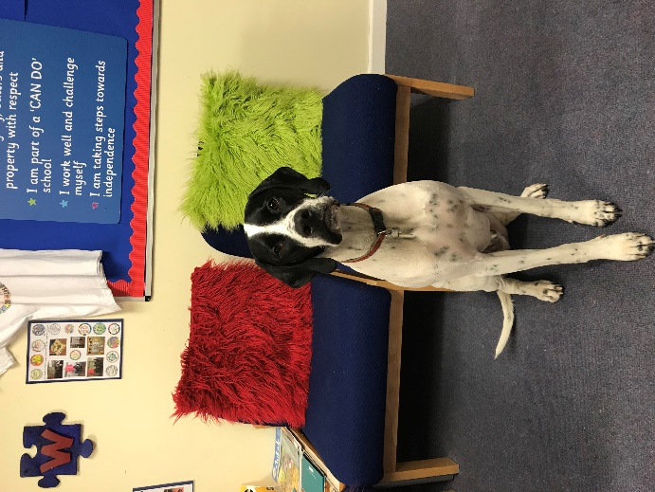
has the kennel club gold award.

Clyde is around the school, often goes out on the playground and loves being fussed! We use him in situations which may benefit children. This may include “reading time” with Clyde, telling him their worries and therapeutic stroking.

We use Clyde to teach dog safety around all dogs.

He is closely supervised when in contact with children.


If you would like to discuss Clyde with Erika our headteacher, or pop in and meet him, feel free to get in touch.
Children are generally very positive about Clyde and enjoy interacting with him.



Float Therapy
Float Therapy deliver a programme run by Behaviour Specialists and Qualified Counsellors.
They come into Jigsaw for a few hours each week to further support the work of the Jigsaw Team. Children will be selected for the programme based on their needs. Not all children will access the service.
Float Therapy aims to promote:

- Anger Management Skills
- Communication skills
- Talking and Listening

All sessions will be delivered in child-friendly and sensitive style on a needs led basis. This may mean that your child will receive several sessions over a number of weeks or just a one off session on a given week.
Our therapist will be Penny Roscoe-Jones who may be in contact with you to provide valuable feedback from her sessions when appropriate. Please do not hesitate to contact Jigsaw if you wish to talk with Penny.
Before and after taking part in the programme, children will be asked to give their feedback on how they think the sessions have helped them develop new skills.
You will be asked to sign a consent form to approve Float Therapy.

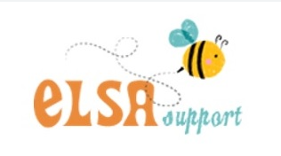
What is an ELSA?

ELSAs are Emotional Literacy Support Assistants. They are a specialist with a wealth of experience working with children. ELSAs are trained and regularly supervised by Educational Psychologists. Jigsaws’ current ELSA, Mrs King, has experience supporting children with additional needs, a BSC Psychology Degree (Hons), a Masters in Social Work and Child Protection Safeguarding knowledge.
An ELSA is a warm and caring person who wants to help your child feel happy in school and reach their potential, in all areas of their life. Their aim is to build your child’s emotional development and help them cope with life’s challenges. The ELSA will help your child to find solutions to any problems they may have. We our happy to work alongside any other professionals / therapists in your child’s life. Please feel free to talk to the ELSA if you have any concerns about your child’s emotional development.
Jigsaw staff will refer your child to the ELSA and together, with parents/carers, complete an assessment on what areas we wish to develop and monitor your child’s emotional development for a set period of time, usually 6-12 weeks however, this can vary. We will then review the ELSA input and child’s progress.
What can ELSAs help with?
*Anxiety *Bullying*Conflict*Emotional Literacy*Emotional Regulation*Friendship Issues*Loss and Bereavement*Managing strong feelings*Relationships*Growth Mindset*Self-esteem*Social skills* Social Stories
Individual or Group sessions:
Usually, 6-12 sessions will be offered initially and this will vary according to the age and needs of the child. Sessions can be 1-1 or as a group of pupils together.
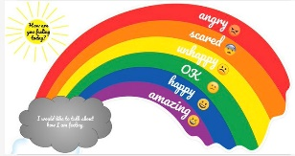
An example of a session is:
Emotional check in- ELSA welcomes the child/ren and checks how they are emotionally using an Emotion Thermometer or the Roar Rainbow.
Warm up activity – Bubble Tennis
1-3 Main activities- Puppet role-play, ‘feeling detective’ games, reading about ‘Ravi’s Roar’, ‘Ruby’s Worry’ or ‘Starving the Anger Gremlin’.
Relaxation/Check out – Sessions will end with a relaxing task such as feather drawing, creatively eating a snack.
Safeguarding protocol
At Jigsaw the safety of all of our children is paramount. We are committed to promote and safeguard the welfare of our pupils. We have a responsibility to recognise signs of abuse and neglect and will follow our child protection procedures to ensure our children are protected. Keeping children safe includes issues that may arise within school and at home, in person and online.
Within Jigsaw, we endeavour for all staff to provide a safe environment for our pupils. Jigsaw ensure staff are inducted through robust recruitment procedures, trained appropriately and know how to respond to any safeguarding concerns timely and efficiently.
Jigsaw welcome families to share any difficulties they are having at home so that we can offer non-judgmental advice which may include sign-posting to services which could be beneficial to help families manage their situation.
Jigsaw staff have a moral and statutory responsibility to pass on information which we deem concerning about a child’s welfare. When possible, we would discuss any concerns with the parent/carer and inform them of our intention to contact Sefton’s Children’s Help and Advice Team (CHAT) for advice, unless we deemed a discussion could place the child at increased risk of significant harm. This process always follow confidential multi-agency sharing protocols. We appreciate this can be an unsettling time, we hope to support our families during this time and all act in the best interest of the child. The outcome of this could be that families may benefit from additional services which could include involvement from the Family Wellbeing Centre, Mental Health Support Team and/or Sefton’s Children services to provide advice and support to help families flourish.
Jigsaw Designated Safeguarding Leads (DSL) Team:
Lead DSL: Ms Erika Rothlisberger (Headteacher)
Deputy DSL: Mr Chris Mathews (Deputy Headteacher)
Deputy DSL: Mrs Sarah King (Liaison Officer)
The Safeguarding governor is Mrs Clare Evans
The safeguarding governor’s committee meets termly to review Safeguarding policies, procedures and receive reports from the DSL team.

Attendance Reminder
Jigsaw pupils should arrive at school for 8.50am. Your child would be marked late if they arrive between 9.30-10am and marked as unauthorised if they arrive after 10am following guidance (unless this is down to the school transport or other authorised reasons). If your child is unwell or cannot attend, we ask for parent/carers to ring the main office 0151 934 2485 to inform staff of the reason why and advise of their expected return date. A text could also be sent to the work mobile number 07917950912 if you are unable to ring the office. If you do not contact the school, we may contact your emergency contacts and a home visit from Jigsaw or their Home School could take place to confirm the reasons for your child’s absence. We appreciate that some of our children find coming to school difficult, therefore, by ringing school we can have a conversation about how to best support your child and family.
Key Aspects of the Sefton Absence Policy
- Types of Absence:
  - Authorised: Absences for valid reasons such as illness or medical appointments.
  - Unauthorised: Includes avoidable absences, shopping, birthdays, or holidays not agreed upon by the school.
- Persistent Absence: Sefton Council monitors attendance data, focusing on "persistently absent" pupils to provide support and, if necessary, take legal action.
- Leave of Absence: Headteachers may not grant any leave of absence during term time unless there are exceptional circumstances.
- Penalty Notices: Unauthorised leave, including holidays, can trigger a penalty notice. A penalty notice may be requested for 10 sessions (5 school days) of unauthorized absence. Penalty charges will be £160 if paid within 28 days reducing to £80 if paid within 21 days per parent/carer per child. A second offense within three years is charged at £160 if paid within 28 days.
- Third Offense: If a third unauthorised absence occurs within three years, the local authority may move directly to prosecution.
- For children with a social worker: In Sefton, part of our planning to improve outcomes for children with a social worker is being committed to improving their attendance and reducing persistent absence. Therefore, if your child is absent and has not been seen in school that week, a request for a First Day Response (FDR) visit will be actioned and a member of Sefton’s attendance team may visit.
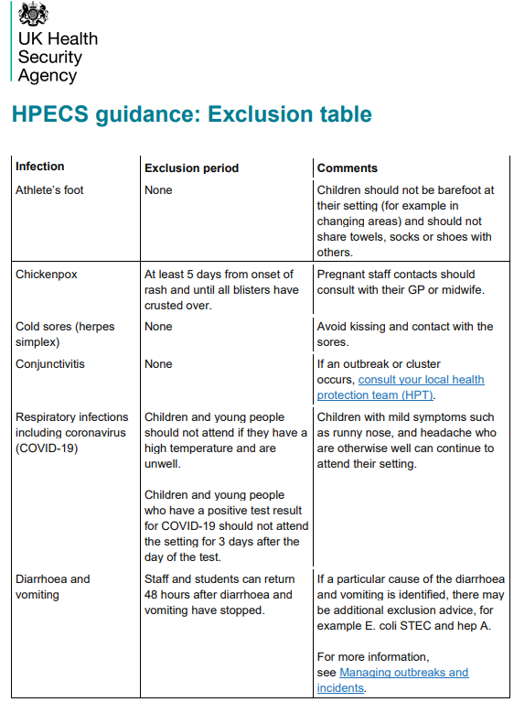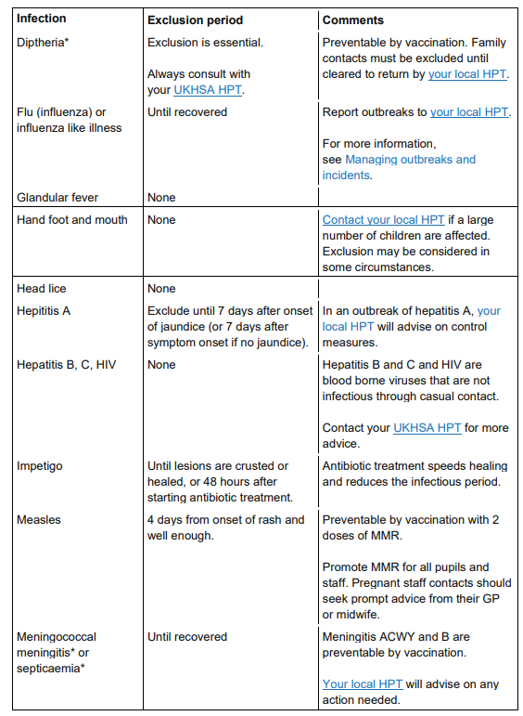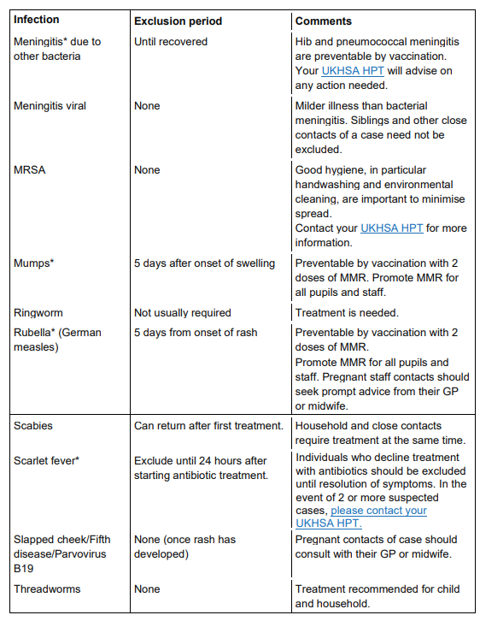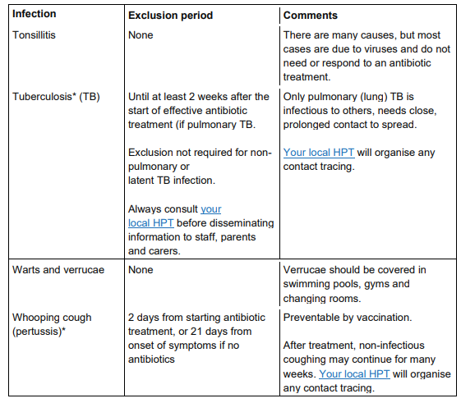
This table should help you make your decision if your child has an illness that requires an exclusion period, please ring the office for advice if required.

