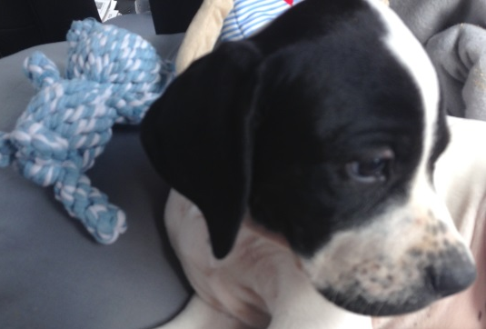
Clyde the English Pointer
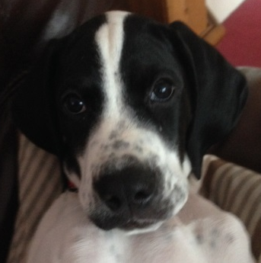
As part of the support that we offer to pupils at Jigsaw, we have a dog who comes into school. Clyde is an English Pointer and was born on the 17th May 2017,

Clyde has attended training classes and is doing very well. He will continue to be trained and hopefully be a wonderfully obedient dog.
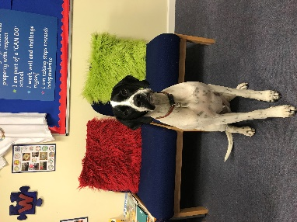

Clyde is a “School Pet” dog.

The pupils will be introduced when they arrive, with your permission and we will be teaching them about appropriate behaviour around dogs. He is very affectionate and enjoys being around children. He loves playing with my own daughters everyday . As he is a young dog, he still has some behaviours we’re working on – such as pinching toys, chewing things he shouldn’t and trying to play with people by mouthing them. Whenever he is with children in Jigsaw, he will be closely supervised and we will make it clear that children aren’t for chewing!
Clyde is used for “reading time” with Clyde, telling him their worries and therapeutic stroking.
If you would like to discuss Clyde with me, or pop in and meet him, feel free to get in touch.
Responses to Clyde have been very positive. So I can understand you wishes and feelings, I would appreciate it if you could return the attached slip.
I’ve also enclosed some leaflets about interaction with dogs
Regards
Erika Rothlisberger (Headteacher)

Clyde – Jigsaw Dog

Please you could you complete the following and return to Jigsaw.

Please tick all that apply
I have received information about Clyde the English Pointer at Jigsaw □
I understand that Clyde will become an active part of life at Jigsaw – moving around the school □
I would like my child to interact with Clyde □
I would like my child to touch Clyde whilst supervised by an adult □
I would like to discuss Clyde further □

You child’s name ________________________________________
Date _________________

Your name _____________________________________________

Signature ______________________________________________

